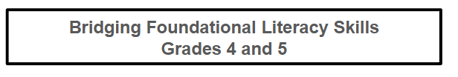
These recommendations will help you support your child in meeting the reading expectations for fourth and fifth grade. All guidance is aligned with the science of reading.
If your child is more than one year below grade level, please begin with my recommendations for Grades 2–3, which will help build foundational skills first.
Home support plays a critical role in a child’s academic success. Even older students who have gaps in foundational reading skills can still catch up. By engaging in your child’s learning and following these recommendations, you will help reinforce school instruction, build confidence, and create consistent, effective learning habits.

Catching Up a 4th or 5th Grade Struggling Reader

Table of Contents
- Phonics
- Decodable Texts
- Reading Expectations
- Sight Words
- Vocabulary
- Reading and Listening Comprehension
- Screener Commonly Used in Schools
- Tech Option
- Grades 4 and 5 ELA Common Core State Standards

Disclosure: Some links on this page are affiliate links. I earn a small commission if you purchase at no additional cost to you. This helps support free content on the site.

1. Phonics

Teach Syllabication
Syllable division rules give older struggling readers powerful tools for decoding multisyllabic words. These rules are fun to learn and will help your child read any word.

Teach Decoding and Spelling in a Systematic Order
Use this reading and spelling sequence.
Your child should master each column before moving on to the next.

2. Read Decodable Texts—Tap and Blend to Solve Unknown Words
Read, reread, reread, and reread decodable passages. Talk about the stories as a quick comprehension check.
How to Read a New Passage With a Struggling Reader:

- Discuss the new phonics concept introduced in the passage.
- Read the passage aloud while your child follows along, and you point to each word.
- Echo read the passage, sentence by sentence, continuing to point to the words.
- Read together chorally (reading at the same time), still pointing as you go.
- Have your child read the passage independently, repeating the reading until it becomes fluent. Ensure your child continues pointing so you can confirm they are reading, not reciting from memory.
- Optional: Ask your child to highlight words that contain the new phonics pattern, and assess spelling on the pattern.

As an Amazon Associate, I earn from qualifying purchases.
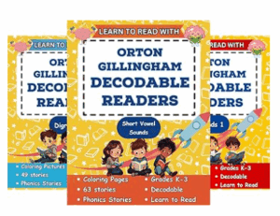
Here is an optional tool. The Orton-Gillingham 13-book decodable series progresses systematically from CVC short-vowel stories to compounds and multisyllabic words. These affordable readers are thorough and helpful for parents and teachers.
My favorite free passages, however, are from UFLI. UFLI decodables align with systematic phonics instruction. Every word can be decoded and encoded, reinforcing sound–spelling patterns through reading and writing. As skills grow, students develop accuracy, fluency, and confidence with connected text.

- All UFLI Decodables on One PDF 8-128 (There are no decodables for lessons before 8.) If your child is a struggling reader, start at story 8, otherwise, start at 35.
- Supplemental Decodable Texts—these are more challenging and don't include every lesson. I use these with my older readers.
Research strongly supports the use of decodable texts as the most effective method for teaching early reading.
When your child encounters an unfamiliar word, always prompt:
“Sound it out.”
Most words contain at least some decodable elements, even if not fully phonetic.
Focus on Tap for Teens and Adults. This app has mature themes and is for teens and adults with dyslexia. I believe it is $2.99 per book via in-app purchase.

3. Expectations When Reading Any Text

Accuracy
Your child should make no more than 10 errors per 100 words (including words you had to tell them).

Comprehension
4th and 5th graders should be able to:
- Summarize
- Explain the author’s lesson, citing evidence.
- Identify the most significant event in the story and explain its importance, providing supporting evidence.
- Answer any question, citing evidence.

Fluency
Fluent reading supports comprehension.
Use this formula to calculate Words Correct Per Minute (WCPM):
WCPM = (Number of words read correctly ÷ Seconds) × 60
Example:
Child reads 207 words correctly in 205 seconds (3:25)
207 ÷ 205 ≈ 1.0 × 60 = 60 WCPM

What Counts as an Error?
- Mispronunciations
- Skipped words
- Out-of-order words
- Substitutions
- Words not self-corrected within 3 seconds

Do NOT Count as Errors
- Repetitions
- Self-corrections (if made within a few seconds)
- If a line is skipped, redirect the child.

Expected WCPM
Approximate averages:
Grade 4: By June, the average 4th grader should be reading 133 correct words per minute (WCPM).
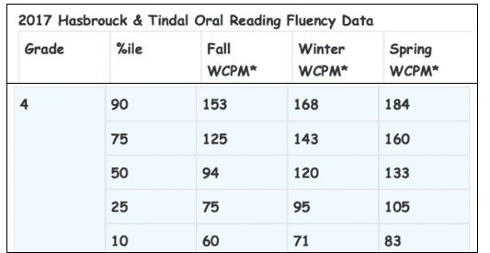
Grade 5: By June, the average 5th grader should be reading 146 correct words per minute (WCPM).
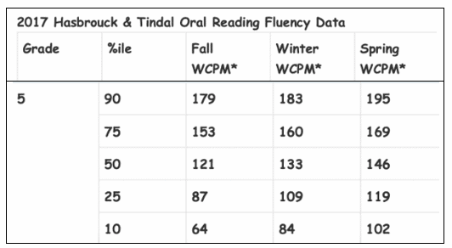

4. Sight Words
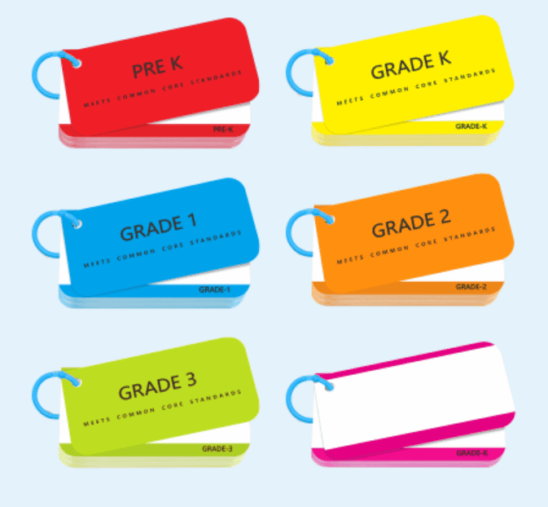
Here are sight-word flashcards based on grade level! Practice just a few each day.
By grades 4–5, students should read and spell all Dolch sight words. Here is a handy list.
Sight words are best learned in context, so practice these stories.
Decodable-Dolch-Sight-Word-Stories-Preprimer-Grade-3

For more practice, write each sight word in your own simple sentence so your child can practice reading. Here are more sight word stories!

5. Vocabulary
Vocabulary grows rapidly in Grades 4–5.

Grade 4 Vocabulary List
This list is based on the Marzano Academic Vocabulary set.
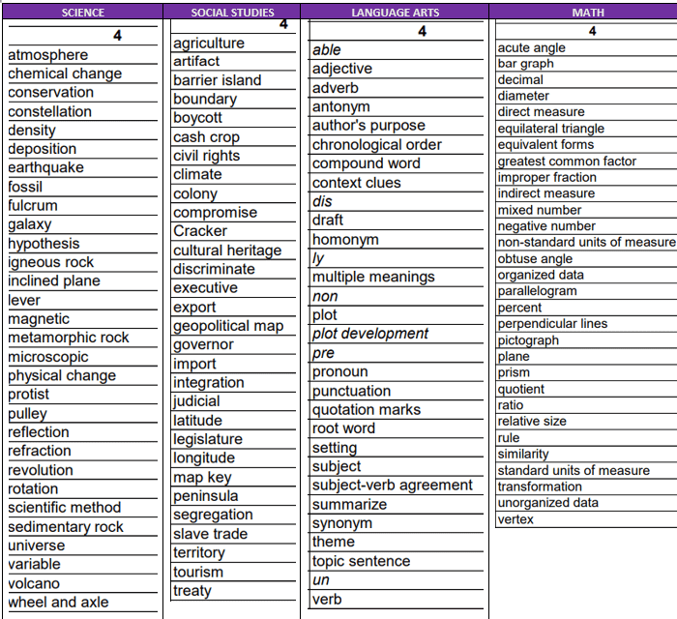

Grade 5 Vocabulary List
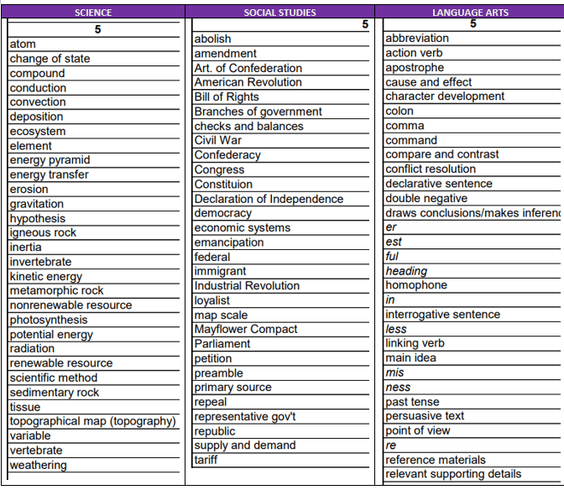
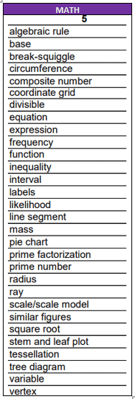
Furthermore, look at Words to Know by Grade Level.
4th-grade words are on pages 7-9. 5th-grade words are on pages 10-12.
Practice tip:
Have your child say the word, define it, and use it in an oral or written sentence.

6. Read Aloud to Your Child or Have Them Listen to Online Texts (with Closed Captions)
Listening to more complex books helps:
- Build vocabulary
- Strengthen listening comprehension
- Encourage a love of reading

Comprehension Guides
These are the same tools teachers use in school:
- Grade 4 and 5 Comprehension Strategies
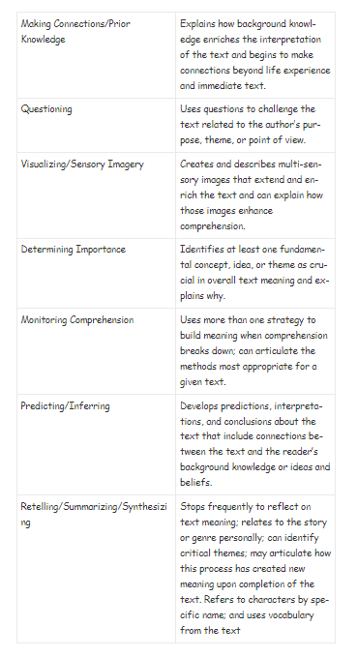

7. Screener Commonly Used in Schools
The DIBELS 8 assessment includes several one-minute subtests. The MAZE comprehension subtest, however, is three minutes. All students are assessed 3 times a year. In Grades 4 and 5, students are assessed in Oral Reading Fluency (ORF) and MAZE. Follow the DIBELS 8 link to test your child yourself. There are many progress monitoring tests to use.

1-Minute Oral Reading Fluency
To meet end-of-year expectations:
- Grade 4: 125 WCPM with 96% accuracy
- Grade 5: 137 WCPM with 96% accuracy

3-Minute Maze Comprehension
Students read a passage with missing words and choose the correct one from three choices.
The minimum scores to pass for grade 4:
 | Fall | Winter | Spring
Oral Reading | 87 | 121 | 125
MAZE Comp. | 14.5 | 16.5 | 17

The minimum scores to pass for grade 5:
 | Fall | Winter | Spring
Oral Reading | 103 | 122 | 137
MAZE Comp. | 13.5 | 17 | 21

8. Technology Option

Lexia Core 5
A research-based, science-of-reading-aligned program used in many schools.
A home version is available for $175 per year. It covers grades PreK–5 and includes phonics, fluency, comprehension, vocabulary, and phonological awareness. It actually teaches your child and tracks progress.
My school uses Lexia Core 5, and it is extremely effective for struggling readers.

9. Grades Four and Five ELA Common Core State Standards
The Common Core standards require students to read stories, literature, and more complex texts that provide facts and background knowledge in areas such as science and social studies. Students will be challenged and asked questions that push them to refer back to what they’ve read. This emphasizes the critical thinking, problem-solving, and analytical skills required for success in college, career, and life.

ELA Common Core State Standards
- Grade 4 is on pages 52-56.
- Grade 5 is on pages 67-71.

Check these out:
- ELL Resources
- Common Core Reading Literature Strategies
- Common Core Strategies Informational Text

Parents and Teachers! Refer to the skills children need in their grade!

This page was last updated on December 31, 2025.

